For us, the primary AZ is us-east-1b and the secondary AZ is us-east-1a as seen below:

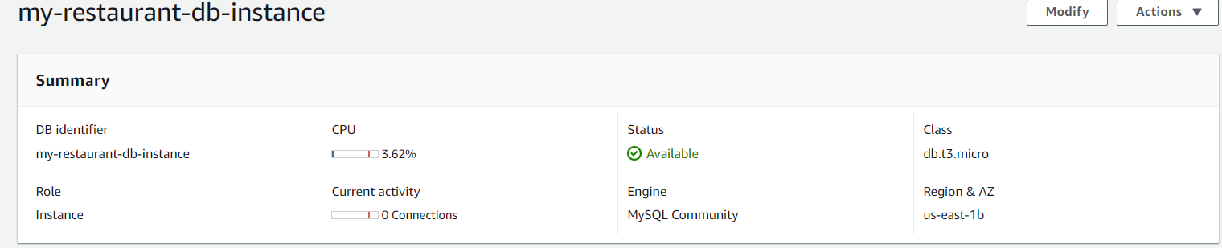

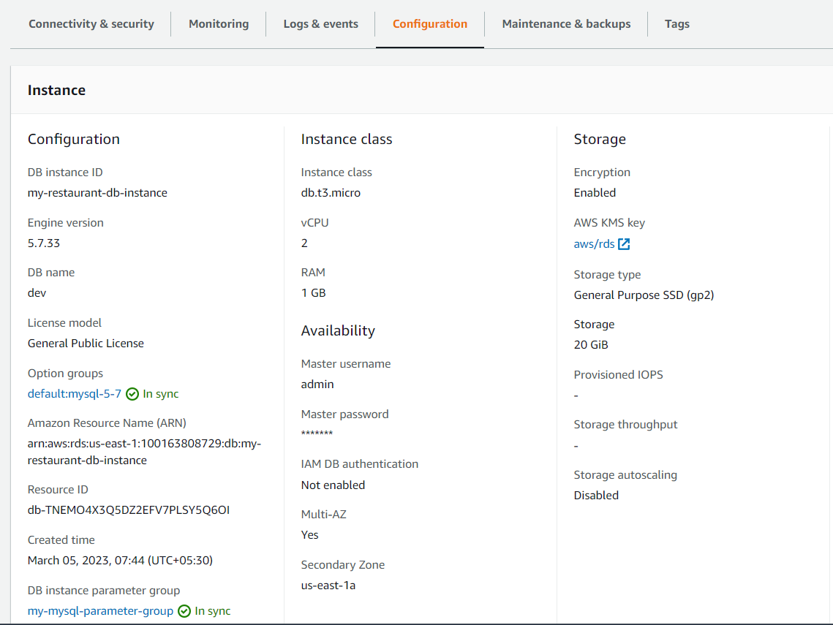

If, for some reason us-east-1b becomes unavailable, us-east-1a will automatically become Primary db and us-east-1b will be come secondary. us-east-1b will get synced up whenever the AZ comes back up.

Even when us-east-1b is unavailable, you must be able to submit recipes, get the ‘Thank you for participation’ message and the submitted recipe must be displayed. This will show that the Multi AZ deployment has served its purpose of high availability.